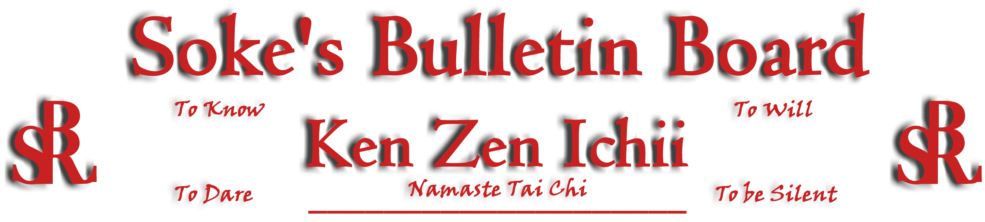
www.kenzenichii.com

January 2011

House of Soke
Congratulations and best wishes to Shihan Childress on his move to the Seattle, Washington area. Shihan Childress’ new contact information is on the Ken Zen Ichii website.

House of Soke II
Congratulations to Sensei Nigel Edwards on his December 2010 graduation from UNC Chapel Hill Law School.

Thank you to Kyoshi Montgomery, Kyoshi Leary, and Shihan Dellinger on their recent Blackbelt Seminar covering weapon attacks and defenses. Thank you to Sensei Trent Bullock for coordinating this event.
BSR Modern Martial Arts School
All is going well.

Sapphire Dragons
All is well with the Sapphire Dragons.

We wish everyone a very happy and joyous holiday.

Ken Zen Ichii Japan
Wishing everyone a very Merry Christmas and a very Prosperous New Year.
KZI - Tennessee
All is going well.
We will be holding a self-defense workshop on Jan 22, for Friendship World Outreach (FWO).

Crush Fitness
New Year Resolutions: A New Year resolution is a commitment that an individual makes to a personal goal, project, or the giving up of bad habits. It could be to lose weight and getting in shape, quit smoking, or learn something new, letting go of the past, or enjoying life more.

Wishing all of our Ken Zen Ichi Black Belts a Happy New Year filled with new beginnings and positive change.

Congratulations to Sensei Thaje Jeanty for a great fight at Danbury Police Activity Center on 12/11.

Congratulations to Sensei Pierson Bisceglia on his nomination to National Youth Leadership

Congratulations to Morgan Blatz, Kaitlyn Heyward and Jacob Moore on their A average in school.

Classes will be sparring and/or grappling on Friday, January 14th at 6:00 & 7:00pm. Please bring all necessary, mandatory safety gear.

Class preparation: When you go to school you are expected to be prepared by having your supplies, paper and notebooks with you. The same expectation is in karate by bringing your gloves, mouth pieces and any safety gear. Having this gear is not only for sparring days but also for training purposes. It is not the parent’s responsibility to bring your son or daughter’s equipment but the responsibility of the student.

KZI NEWSLETTER – January 2011
Page 2 of 2

Hudson Valley RyuTe Kan
All is going well.

Miscellaneous
Season’s Greetings for all and have a blessed New Year…Sensei Michelle Caraway

85% of martial arts students are under the age of 13 years old, although you are never too old for karate.

Many Masters patented their styles, who taught it to their students, creating sub-styles.

Gichin Funakoshi in Japan from the 1920s is considered today the "Father of Karate".

Pearl’s of Wisdom
“The best relationship is not the one that brings together perfect people, but the best is when each individual learns to live with the imperfections of others and can admire the other person's good qualities.”

To Know, To Dare, To Will, To Be Silent…Shihan Baker
When I was a student going through the ranks of karate, earning each belt meant a lot to me as I knew I was getting better as a martial artist. The words in each corner of the KZI certificate were just words and passed by with each initiation into another rank. I never truly reflected on them or questioned their meaning until I stood as a Sensei and read those words as I promoted students. Those few words began to hold a much deeper meaning and moved me with each promotion. These words passed the torch from Sensei to student to another rank. The interpretation of these words changes with each passing year or another initiation. When I read those words, I could see and feel my own journey in the art.

To Know: is to accept and know who you are and the truth about oneself with no false pretenses, to try and hear the message, and not to defend your point of view all the time, to empty your cup, to yield when appropriate. To Know: We don’t have all the answers and that we keep learning and growing with each passing year and understand how our behavior affects others. It’s knowing that it’s not all about me, it’s about the student.

To Will: Is to “turn on the switch” when we have to, never give up and trust yourself and trust spirit. To keep going forward, put one foot in front of the other and stay on the path. When we are brought to our knees we get back up. When all else falls away, we are still standing. To Will: Is that we have choices and we do what is required with discipline and focus.

To Dare: Is to have courage even when we feel fear. We all feel fear but it’s the admitting and accepting of it that there is strength. We Dare: When we take a risk, step out of our comfort zone and follow our path even when others may not approve or support us, we do it anyway.

To Be Silent: is knowing the wisdom to hold our council. It is not always having our say but to absorb from others and reflect on the message. It’s listening to the inner voice and let out intuition guide us with discernment.

To Know, to Will, to Dare, to Be Silent, a simple philosophy to live by but yet holds great depth and spiritual wisdom.

Editor’s Notes
Articles for the Ken Zen Ichii website and newsletter are being actively solicited. Anyone who wants to submit an article should contact Sensei Michael Calabrase at mcalabrase@bsrwarriors.com or the editor at Noah_Valle@hotmail.com, (818) 395-0757.

